**Satish Pradhan Dnyanasadhana College**



**Project Title:**

ORGAN DONATION APP

Academic year: (2020-2021)

**Submitted By:**

Sahil Sandesh Peje

Roll No: 62 **Guided By:**

Prof. Rajmohan Yadav

**Problem Statement :-**

India has only 301 hospitals that can perform organ transplantation which means there exist only one hospital equipped for organ transplantation and retrieval for around 43 lakh people. But lack of infrastructure is only one of the issues hampering organ donation in India. The demand for organ transplantation has rapidly increased all over the world during the past decade due to the increased incidence of vital organ failure, the rising success and greater improvement in posttransplant outcome. However, the unavailability of adequate organs for transplantation to meet the existing demand has resulted in major organ shortage crises. As a result there has been a major increase in the number of patients on transplant waiting lists as well as in the number of patients dying while on the waiting list.20 people died each day because of organ transplant. I have created this project because of every 10 minutes another person is added to the transplant waiting list.112,000+ Number of people on the national transplant waiting list as of march 2020.

**Abstract :-**

The need for organs for donation is far greater than organ availability. In the last decade this has led to restructuring and investment in the organ donation programme with political and public support. The majority of transplanted organs are retrieved from patients dying on an intensive care unit, and the wish to consider organ donation as a normal part of end-of-life care has led to considerable pressure on clinicians. Organ Donation in India has always been on a lower side and around 5 lakh people die every year in India due to unavailability of organs. Nearly 2.2 lakh people await kidney transplant, of which around 15,000 end up receiving a kidney. At a given point of time, about 1 lakh people die of liver diseases in India and only 1,000 get liver transplant. A death or death donor can save up to 8 lives, but despite this organ donation is a neglected issue. Lack of knowledge, awareness, infrastructure are some of the reasons behind shortage of organ donation in India.

**Introduction of System :-**

This android application will help user to get organ from donor. This system has two entities namely, Admin and User. Admin can login using credentials. admin can view all Doctors and they can add, update and delete Doctors. admin can view and assign Doctor, Donor. they can also Chat with User via doctor mobile number. admin can view list of donor, receiver and user list. User can register and login using credentials. If they forget password, send an email with reset Password. User can change their password in case of security. User can also check the assigned doctor and donor via SMS and can Chat with the admin using number**.** They can select and view doctors list. Notification on admin assigning doctors and donors to the request. They will also get notification of their chats.

**Objectives :-**

**The main objective of our project are :-**

* To evaluate current possibilities that transplantation to the patients.
* To propose alternatives to modify this medical and social crisis.
* To provide a better facility to medical field.
* Encourage people to talk to others about the importance of organ donation.
* To educate the people about organ donation.

**Block Diagram :-**

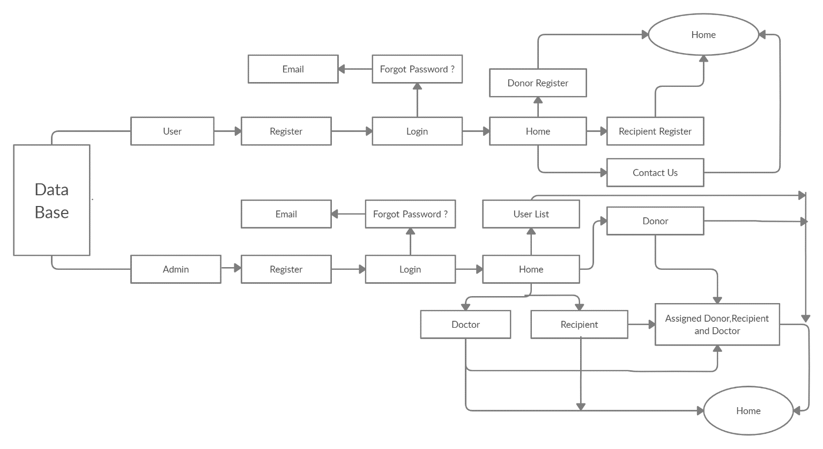

**Module Division/Module Explanation:-**

The system comprises of 2 major modules with their sub-modules as follows:

1. **User :-**

**Register:** User can register and obtain credentials.

**Login:** User can login using credentials.

**Forget Password:** send an email reset Password.

**Home:** There will be three slots Recipient, Donor and Contact.

**Recipient:** User can manage request by adding and updating request. User can also check the assigned doctor and donor etc. and can Chat with the Admin**.**

**Donor:** User can add details.

**Contact us:** User can see doctor numbers and contact them.

**Notification:** Notification on Admin Assigning doctors and donors to the Request. They will also get notification of their chats.

1. **Admin :-**

**Login:** Admin can login using credentials.

**Manage Doctors:** Admin can view all Doctors and they can add, update, view and delete Doctors.

**View Organ Request:** Admin can view request of recipient.

**View Donor List:** Admin can view list of donations.

**View Users List:** Admin can view user list.

**Assigned Recipient:** Admin can assign doctor, donor to the recipient.

**Contact us:** Admin can see doctor numbers and contact them.

**Advantages:-**

* + The proposed system will save significant amount of time and effort.
  + The System fully works as an online.
* This system is user friendly.
* Doctor and User can directly connect to each other.

**Disadvantages:-**

* Evaluate to match the process large amount of data.
* Data need to be entered properly otherwise, outcome may won’t be accurate.

**Hardware Requirement:**

1. **Laptop or PC :-**
   * i3 Processor Based Computer or higher
   * 4GB RAM
   * 1 TB Hard Disk
2. **Android Phone or Tablet :-**
   * 1.2 Quad core Processor or higher
   * GB RAM

**Software Requirement :**

1. **Laptop or PC :-**

Windows 7 or higher.

Java

Frontend :- Android Studio

Backend :- Database(Firebase)

1. **Android Phone or Tablet :-**

Android v5.0 or Higher

**Future Scope :-**

The Organ Donation App is Android based application which will be helpful for Donate and Receive organs. This project will be great helpful for the medical field because, It is a great helpful to save another person life, It is difficult task that to manage huge data.

**Conclusion :-**

Organ donation can save a person’s life. Its importance must not be overlooked. A proper system should be put in place for organ donation to encourage the same. Most of the countries around the world suffer from low organ donor rate. The issue must be taken more seriously. Laws to increase the rate of organ donation must be put in place to encourage the same.